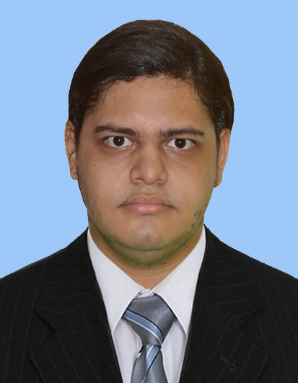

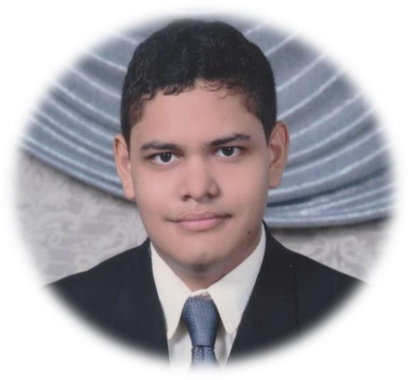

Diego Alexander Alemán Castro

# Contacto:

[DiegoAleman_@Outlook.com](mailto:DiegoAleman_@Outlook.com)

# [LinkedIn:](https://www.linkedin.com/in/diego-alexander-aleman-sv/)

[Diego Alexander Alemán Castro](https://www.linkedin.com/in/diego-alexander-aleman-sv/)

**Goals:**

- Being a successful professional.

- Being able to develop as a professional in the area of cybersecurity.

- Always acquire new knowledge that helps me improve as a professional.

- Collaborate efficiently in large teams in a professional manner.

# Resumen profesional

I am a university student who loves cybersecurity and computer networks, my specialty is controlled and ethical penetration testing of public and private business devices, I am also someone certified in the management audit of information systems and with the capacity to manage custom networks for companies or individuals.

# hard skills:

* Pentesting - Red Team.
* Etical Hacking.
* certified as internal auditor ISO27001.
* certified as Ethical Hacking Certified Associate (EHCA).
* Computer network manager.
* Use of Kali Linux tools, Metasploit. Nmap, John the Ripper, OS Cisco, etc.

# Soft skills:

* Planning and time management..
* Flexibility.
* Decision making.
* Negotiation.

# Professional Values:

* Ethical.
* Responsible.
* Honest.
* Solidary.

# Featured Badges:

